Easy Read

Application form for Mencap volunteers

We are Mencap. These are our values:
- We want to make the world a better place.
- We want to include everyone in the work that we do.
- We do not fear to try new things.
- We encourage and support each other.
- We are kind to everyone.

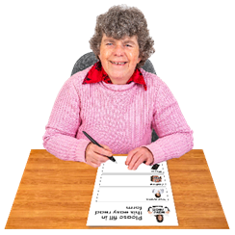
If you would like to be a volunteer with Mencap, please fill out this application form.

Data Protection
We follow the Data Protection rules. Data Protection rules means you have to follow strict rules when using someone’s personal information.
All the personal information you give to us will be kept safe and will only be seen by the volunteering team and the volunteer Manager

We will keep your information for 7 years.

Your details

Name:
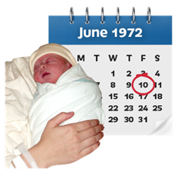
Date of birth:

Address and postcode:

Phone:
Email address:

Questions

- Why do you want to become a volunteer a Mencap?

- Tell us about the skills and experience that you can bring to the role. We will give you any training you may need to do the work.

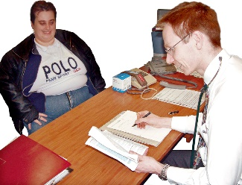
- Do you have any medical conditions?

Yes ☐ No ☐

If yes, please tell us about it. Tell us what we should do if there is an emergency and if you need help.

- Do you have any other support needs?

Yes ☐ No ☐

If yes, please tell us about it, so we can support you.

- Do you have a learning disability?

Yes ☐ No ☐

Declaration
I confirm that the information I have given is true.

I agree that if any information is not true or if I have missed out any important information, I may not be able to get the job as a volunteer.
Signed:

Date:

Would you like to get our monthly online magazine called Connect?

Yes ☐ No ☐

