At Mencap, we want to work with people who live in Wales.

Please tell us about your community in Wales!
A community is a place where people live.
It can be a city, town, village or neighbourhood. It can be your local area.
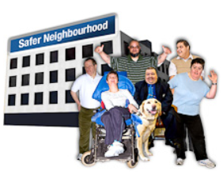

Mencap wants to help your
community be the best place for people with a learning disability to live happy and healthy lives.

Across the UK, we are working with 9 different communities on this project.

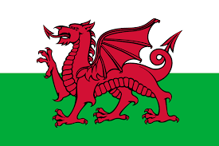
We are looking for one more community in Wales.

Do you love where you live?

Would you like to make it an
even better place for people with a learning disability to live?

We would like to hear from you. (picture of someone talking to others. Engaging. Speech bubble.)

If you would like to tell us about your community, please click this link to let us know.

If you need any support to complete the form, please tell us.

Or you could send us a short video telling us what you love about where you live.
This Photo by Unknown Author is licensed under CC BY-NC-ND

You can get in touch with Eve by email or phone.

You can email us at mycommunity@mencap.org.uk.

Or you can call us on 07929 669 969.

We would like to hear from you by 31st January 2022.

Thank you!

