If you have a Learning Disability, having your name on your GP Learning Disability register is important.

You may get invited to health checks with your Doctor every year, to make sure you are staying safe and well.

This year people on the register got their Covid vaccination early.

But lots of people do not know about the Learning Disability register and they are not on it. So they are not able to get the support they need.

We need to tell more people from BAME communities about the Learning Disability register.

If you are a group that can reach people with learning disabilities from Black and Asian communities, you can apply for funding to help us with this.



Funding

To help people from BAME communities get onto the Learning Disability Register

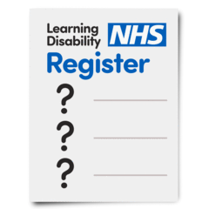

If you are a group that can reach people with a learning disability from Black or Asian communities, you can apply for funding to help us with this.

Mencap want to give funding to organisations that can reach and support people with a learning disability from Black and Asian communities. We can give you up to £4,000 if that is what you need.

.

Mencap are hoping to give funding of between £500 - £1000 to organisations that support people with learning disabilities from Black and Asian communities.

The amount may depend on the number of applications we receive.

The funding must be used to help people get onto the GP Learning Disability register.

Please fill in the form below if you would like to apply for funding.

If you would like to apply for
funding you should first read the Funding Guidance form. This will tell you what you need to do and when you need to finish it by.

What is the name of your group?

If you are happy with this guidance, then complete the application form which is below.

Application form

What is the name of your group?







Application form
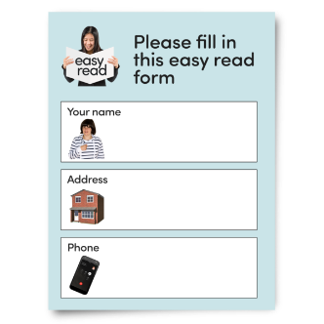

What is the name of your organisation?

What is your charity commission number?

How will you reach people with a learning disability from Black or Asian communities in your local area? How will you make sure they can understand the information you give them so that they can join the project?

In the project, how will you work together with people who are Black and Asian to make plans and materials that include people from Black and Asian communities?

You can use your funding for linking with local people to tell them about the GP Learning Disability Register or organising meetings to talk about the Register.

You might need to pay for staff time, marketing materials, transport, or anything else that would help your group to talk to more people.



If you are successful in receiving funding, what would you use the money for?

How much money do you need for each part of your project?



Please use the box below to add any extra information about your application.


How has your group been involved in the Treat me well campaigning during 2020? (continued)

If you are successful in gaining funding, what would you use the money for?

This could be for:
online meetings,
room hire,
press and media work,
help for people with high support needs.

Do not touch your face, eyes or mouth.
Please return this form by 4pm on
Monday 13th December 2021 to
Regional Campaigns Manager
Stephen John at:

Stephen.john@mencap.org.uk

Please email Stephen or call 07957714560 if you wish to discuss the application in any way.

We look forward to hearing from you.
If your application is successful you will
hear from us before Christmas.

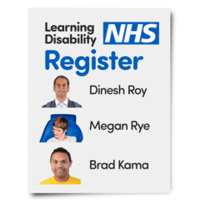

Data Protection statement (non-easy read)

We need your details to administrate your funding application, on the basis of Legitimate Interest (i.e. it benefits your group and Mencap to share this information).

These details will be kept securely for 9 months, and if successful, we will contact you to obtain more information, such as bank details. The bank details will be kept securely for 7 for tax and legal purposes.

We will use the information on your application on an anonymous basis to evaluate the proposals, use and success of the projects and funding awarded.

This will only be shared with the Campaigns Team and might be used in reports and future work in an anonymous way.

You have the right to: obtain copies of the information we hold about you and your application, request that we erase the information, request that we limit the use of the information, and the right to lodge a complaint with the Information Commissioner’s Office. If you have any question about the use of your details, please contact DPO@mencap.org.uk

