Pronouns

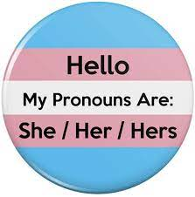
A pronoun is a word that refers to either the people talking (I or you) or someone or something that is being talked about (like she, it, them, and this).

Gender pronouns (he/she/they/ etc.) refer to people that you are talking about. We use pronouns to help us talk about gender. We use pronouns when we talk about trans and non- binary communities.
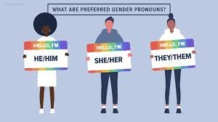

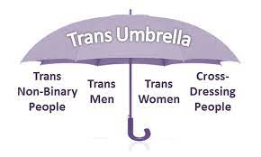
Trans is an umbrella term to describe people whose gender is not the same as, or does not sit easily with, the sex they were given at birth.
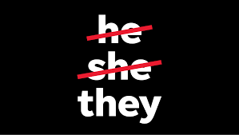
A Non-binary community is a group of people whose gender identity doesn’t sit easily with ‘man’ or ‘woman’.
Non-binary people use they/them to reflect on their gender.


We use pronouns in our e-mail signatures to help avoid getting someone’s gender wrong it also supports our trans and non-binary colleagues and friends by reducing having to repeatedly explain their identity.

Using pronouns is a big part of being an LGBTQIA+ ally.
An ally, is a person who supports equal civil rights, gender equality, and LGBTQIA+ social movements and communities.
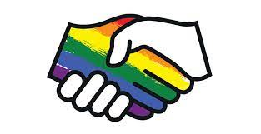

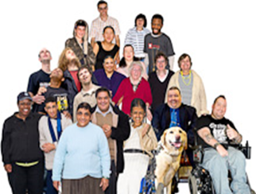
LGBTQIA+ stands for lesbian, gay, bisexual, trans, transsexual, transgender, queer, intersex, asexual communities

Watch our video to learn more about identity, gender and sexuality.

You being you: Your gender and sexuality


