

Mencap Volunteer Application Form
Easy Read

Please complete this form to become a Mencap Volunteer.
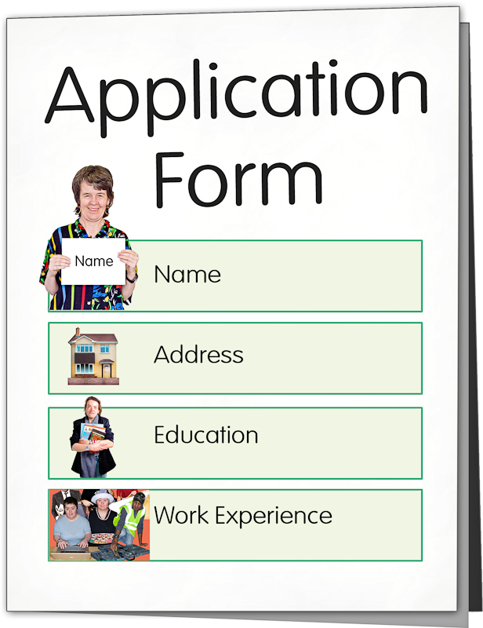
What volunteer role(s) would you like to apply for?

First name


Last name

Date of Birth


Address

Postcode



Phone number


Mobile number

Email


Do you have a learning disability?
(Please circle or highlight your answer)

Yes No


Why would you like to volunteer with Mencap?


Do you need support to volunteer with Mencap? (Such as needing support to travel)

Yes No

If your answer is yes, tell us more about what support you will need.


Is there anything to do with your health that is
important for us to know? (Such as eplepsy, diabetes, anxiety problems or mobility issues)

Yes No

If your answer is yes, tell us more about what support you will need.

How would you prefer us to contact you?
Please tick or highlight the right box

- Phone call on your home phone

- Phone call on your mobile
- Text to your mobile

- Email to you


- Phone call, email or text to your
parent/ carer or support worker

- Phone call, email or text to BOTH
you and your parent/ carer
or support worker

If you would like us to contact your parent / guardian or support worker, please tell us their:

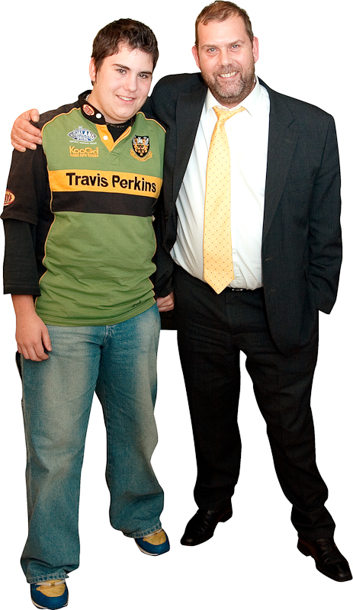
Name:

Relationship to you: (For example: Mum, Dad, Granddad, Support Worker, etc)

Phone number or email you want us to use:


Mencap need to know the name of your Next of Kin so we could contact them in an emergency:

Name:

Relationship to you: (For example: Mum, Dad, Granddad, Support Worker, etc)

Phone number


Date

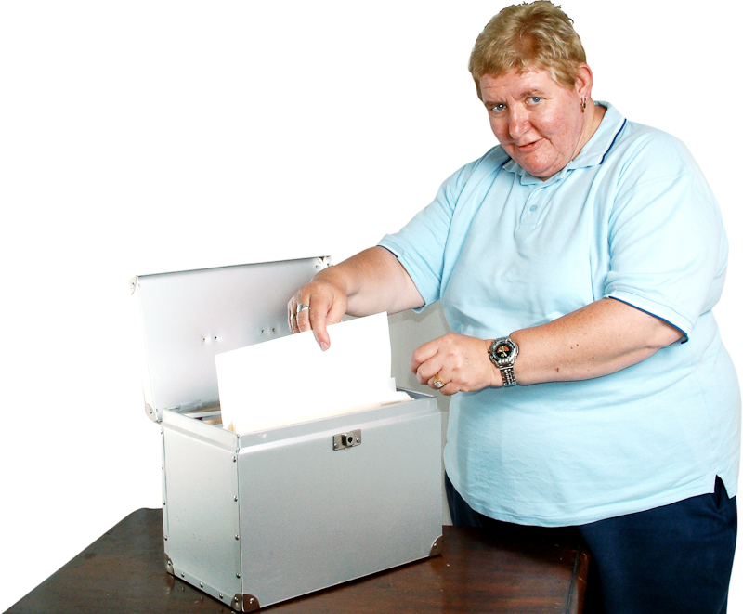
Mencap will keep your information safe.

We will use what you tell us to send you information about:

- Your volunteering and other opportunities
- Mencap and what we do through Mencap magazines and newsletters.

If you do NOT want to receive other information about Mencap, please tick or highlight this box:


Please send this form to Mencap

Post to:
Alison Sammons
Volunteer Recruitment & Reporting Administrator Suite 1
Bermar House
Rumer Hill Business Estate
Rumer Hill Road
Cannock
WS11 0ET

Or email to
Email volunteering@mencap.org.uk

Telephone – 01543 505079

Thanks to Photosymbols for the pictures in this form.

