 | The Gateway Award is an award you get for doing different activities.
 | Activities are things like sport, art, or gardening.
 | It is for people of any age.
 | People with a learning disability can take part.
 | When you do the Gateway Award you can try new activities, be more confident and healthy, meet new people and have fun!
 | The award has three levels: Bronze, Silver and Gold.
 | You can do all sorts of activities for your Gateway Award
 | Hobbies - having interests
 | Fitness - getting active
 | Lifestyle - having a safe and healthy life
 | Volunteering - making a difference
 | Gateway Challenge - do the things you want
The Gateway Award supporter is someone who can help you to do the award. We call them ‘supporters’.

They will help you to choose and do your activities and will tell Mencap when you have done the award.

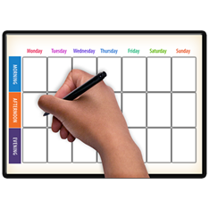 | Choose an activity and plan what you would like to do. Do the activities.
 | Collect proof as you do it and put it in a folder. When you have finished you can start the next activity!
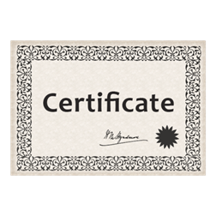 | When you finish the award level you get a certificate and a badge.

To find out more about the Gateway Award please email: gateway.award@mencap.org.uk

