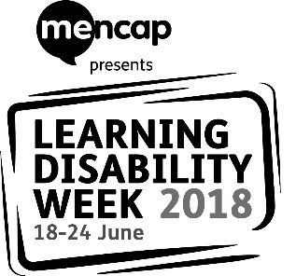

Dear [name of contact here – this could be the learning disability liaison nurse or learning disability lead in the hospital trust]

Earlier this year Mencap launched a new campaign: Treat me well. Treat me well is a campaign to transform how the NHS treats people with a learning disability when they are in hospital. People with a learning disability all too often receive poorer healthcare than people without. But together we can change this, and reasonable adjustments are a big part of this change.

To make this change happen, we want to work with healthcare professionals and other hospital staff to talk about what we think could be better and what we think is working really well.

This year’s Learning Disability Week (18-24 June 2018) is all about health. Across England local events will be taking place in hospitals led by people with a learning disability.

[Name of group or service] would like to hold a stall at [name of hospital] to talk to hospital staff about Treat me well and to give them information that can help them work better with people with a learning disability.
We would love for [name of hospital trust] to celebrate Learning Disability Week with us. Please contact us by email [email address] or telephone [telephone number] so we can discuss with you further.
You can find out more about the Treat me well campaign here: https://www.mencap.org.uk/tmw

We look forward to hearing from you about our event.

Kind regards,

[Your name and the name of your group]

