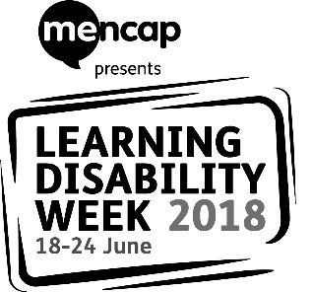

Dear (insert name of contact here – this could be the learning disability liaison nurse or learning disability lead in the hospital trust)

Earlier this year Mencap launched a new campaign: Treat me well. Treat me well is a campaign to transform how the NHS treats people with a learning disability when they are in hospital. People with a learning disability all too often receive poorer healthcare than people without. But together we can change this, and reasonable adjustments are a big part of this change.

To make this change happen, we want to work with healthcare professionals and other hospital staff to talk about what we think could be better and what we think is working really well.

This year’s Learning Disability Week (18-24 June 2018) is all about health. Across England local events will be taking place with people with a learning disability and hospital staff.

[Name of group or service] will be holding an event on [date and time] at [address of where you are holding the event] and would like to invite you or another representative from [hospital trust name] to attend. We would like to talk to you about the campaign and to discuss how we can work together in the future.

Please let us know if you or a colleague can come to our event. You can contact us by email [email address] or telephone [telephone number].

You can find out more about the Treat me well campaign here: https://www.mencap.org.uk/tmw

We look forward to hearing from you about our event.

Kind regards,

[Your name and the name of your group]

