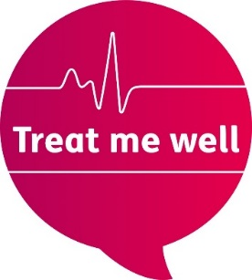
Script for hosts – easy read version
This presentation lasts for 1.5 hours.
You can change the bits with grey highlighting.
Good luck!

   | Welcome everyone to our Treat me well launch event in [place].  Today, there are launch events happening all over the country, including more than a thousand Mencap staff and Network partners.  My name is [name] and I am hosting this event today. Thank you so much for joining us for the launch of our brand new health campaign.  [Go to the Housekeeping slide]
     | Before we start, here are a few bits of information that we need to tell you about.    First, we would like everyone here to fill out the sign in sheet for the event.  This will help us find out how many people took part today.    If you fill it in, Mencap will be able to keep in touch with you about the campaign.  You can get support from [name] to fill out the sheet.    There are no planned fire drills taking place today, so if you hear the fire alarm go off, it’s real. We will leave the building and meet at [say where the fire meeting point is].    There are toilets [say where the toilets are].    We want all people at Treat Me Well events to use social media as much as possible. We want to make lots and lots of noise.      Please use Facebook, Twitter and Instagram to give the campaign lots of buzz on social media. Please use the hashtag #TreatMeWell.    [Tell everyone about the timings of the event. Tell them anything else they need to know about what is happening at your event.]  [Go to the next slide.]
       | Now, let’s hear from Josie, Harry and Jan, the Chief Executive of Mencap, who would like to welcome you to the Treat Me Well launch.  [Play video)  [Go to the next slide.]    As Jan says, Treat me well is a truly One Mencap campaign.  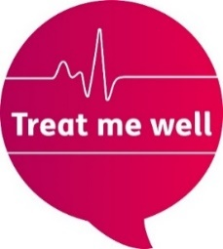  We want everyone in Mencap to understand what Treat me well is about and why it’s so important. Everyone has a part to play.    We want people to describe the campaign in a single sentence: “Treat me well is our campaign to transform how the NHS treats people with a learning disability in hospital”.    When we say transform, that means we want the NHS to make really good changes to hospitals and make them better.    We want everyone here to know that sentence, so that you can use it when you are with your friends and family. Or when you meet someone new in your local area.    The presentation today will tell you much more about why we are doing this campaign and how you can help.  [Go to the next slide.]
   | So, why are we campaigning?  All the numbers I am about to tell you are in the Treat me well campaign report. You can read this on the Mencap website.  Over the last year, the Campaigns and Policy team have been doing lots of research into problems people with a learning disability have with their care in hospital.  They talked to lots of our staff at Mencap. Staff told us that many of the people we support were having a bad time in NHS hospitals.  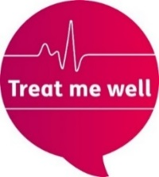  That is a big reason why we are launching this campaign.    They also did a survey to ask 500 people with a learning disability what they thought about hospitals.    They heard that many people wished doctors and nurses would talk to them more clearly.    Many people also told Mencap that hospital staff do not give them enough time to explain how they are feeling and to understand their treatment.    The Campaigns and Policy team also did a survey with 500 health care professionals.    The survey showed us that hospital staff are being let down by the NHS because they are not being given good enough training on learning disability.  1 in 4 health care professionals said they had never had any training. This is shocking.    We think all nurses and doctors should be able to treat people with a learning disability well. Training is a big part of this.    Lastly, Mencap did research through Freedom of Information requests to all NHS Hospital Trusts.    We found out that every trust has a different way of looking after people with a learning disability. Some hospital trusts had a good way of doing this. But lots didn’t.    We think all Hospital Trusts should have a proper plan for this. Treat me well is all about making sure all Hospital Trusts are making the right plans for people with a learning disability.    Another reason why we are launching this campaign is the sad issue of avoidable deaths.  When someone dies avoidably it means they would not have died if they got better care.    An inquiry into this issue in 2012 found that 1200 people with a learning disability are dying avoidably every year.  So we are launching Treat me well because hospital care for people with a learning disability is still not good enough.  [Go to the next slide.]

We have a strong history of campaigning on health. Lots of things we campaigned for in the past have made things much better than they were.


In the 1990s, Mencap ran campaigns like Prescription for Change and NHS for All. These got people talking about unfair access to healthcare for people with a learning disability.

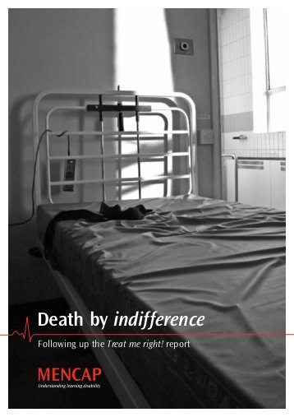
In 2007, we launched our campaign Death by indifference.

This was a campaign that really got people angry inside and outside the NHS.

By looking at the stories of 6 families who had lost people they love in hospital, we showed the Government that this was a huge crisis.

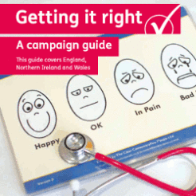
After Death by indifference, we launched Getting it right.

This campaign asked hospitals to sign up to a charter, to make sure they improved care for people with a learning disability.


Many, many hospitals signed the charter and made progress towards its goals.

These campaigns show what can be achieved when we use the strength of our organization to call for change.



But campaigning takes a lot of continued energy, and Mencap’s work on health is not over.

We are launching Treat me well because we know there are still serious problems to address about the hospital care people with a learning disability receive.

These are problems we think it’s time to fix.

[Go to the next slide.]

 | Our campaign will call for two big things to start happening within the NHS.  We do not think training on learning disability should be optional.  We think all staff working in hospitals, from doctors and nurses to people working on reception desks, must have training on learning disability.  Mencap has been piloting new training on learning disability for hospital staff. This training has given us a chance to learn about what works best.    We have put together a list of things we think good training should have. You can read about these in the campaign report.    The other big thing we want to see in hospitals are reasonable adjustments.  Every person with a learning disability has the right to reasonable adjustments in hospital, but often people are not getting them.    Reasonable adjustments in hospital are simple changes to the way the hospital works with someone with a learning disability.  We want every member of staff working in a hospital to know what kind of adjustments might be helpful to their patient.    We also want people with a learning disability, family members and carers to feel confident about asking for these changes to be made.  [Go to the next slide.]
         | When we talk about reasonable adjustments, it can be helpful to think about three main types of changes.  Having more time helps when someone is trying to communicate how they are feeling.    It also helps give the hospital worker a chance to get to know the person better.  An example of a reasonable adjustment which gives someone more time is a double appointment.  Better communication is also helpful. This means using short words and short sentences.  It could mean checking that what you are saying has been understood.    It could mean using other things to help show what you mean, for example pictures or photographs.  Lastly, clearer information is a very helpful reasonable adjustment for many people with a learning disability.  Many bits of information in hospital can be complicated and difficult to read.    Giving people information in Easy Read means that the person being treated can find out about what is wrong with them and why they are being treated.    This short video gives some examples of what reasonable adjustments might help four different people with a learning disability in hospital.  [Play ‘What are reasonable adjustments in hospital’ video]  [Go to the next slide.]
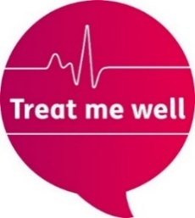 | Now let’s look at what we are actually going to do in this campaign.    Treat me well has four main parts.    Firstly, we want to support local campaigners to call for the changes they want in their local hospitals.  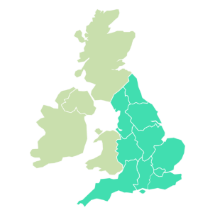  We will be working in 75 target areas around England and Northern Ireland, training up campaigns groups to launch local campaigns.    These groups will be the experts on what needs to change.    Secondly, we are going to be talking to people who work in hospital to make sure they know how to treat people with a learning disability well.    Learning Disability Week is from the 18th to the 22nd June this year.      In Learning Disability Week we will be asking doctors and nurses to join the campaign and become campaigners in their own hospitals.    We will be asking local people to hold events in their local hospital, aimed at raising awareness of the campaign.    Thirdly, we want people with a learning disability, their families and carers to feel empowered to know what good hospital care looks like.    Being empowered means you know your rights and know how to ask for them.      We will be hosting events, writing booklets and creating films to explain what good care looks like.    You can find three brand new Easy Read resources on the Mencap website that explain what your rights are in hospital, how to get the support you need, and what to go if something goes wrong.      And lastly, we will be having meetings with lots of key decision makers from the NHS.    There are many people in the NHS who decide what hospital staff learn in their training.    Our aim is to get them to agree to make sure everyone who works in hospitals is trained about learning disability.    There will be lots of ways for all of you to get involved in each of these four parts of the campaign. Make sure you sign up to join the campaign!  [Go to the next slide.]
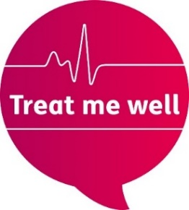 | But first, we have a very exciting moment – the premiere of our Treat Me Well campaign film.    The Campaigns team made this video with a film crew at Guys Hospital in London.  If you like the Treat Me Well campaign film and are on social media, please make sure you share it with friends so as many people get to watch it as possible.  [Play ‘Treat me well campaign’ video]  [Go to the next slide.]
    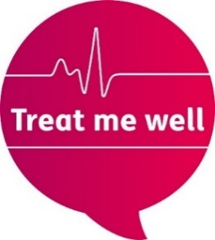   | Now you have watched the Treat Me Well campaign film, it’s time for the main call to action for today.  We would like every person at every Treat me well event to take the Campaigner quiz.  By answering some simple questions, you can find out how you can help the campaign and then sign up.    The best way to take the quiz is using your mobile phone.  Please get your phone out and visit  www.mencap.org.uk/TMWquiz  Make sure to finish the quiz as the final page gives you a link to sign up to support the campaign.    Until you have filled in the sign up form at the end of the quiz, you are not signed up to support the campaign.    If you would like to do a paper version of the quiz, please ask for a copy. Please make sure to hand it in at the end so they can be sent back to the Campaigns team.    There is a prize for the Mencap team that gets the most people to take the quiz and sign up to the campaign!  [Go to the next slide.]
   | Now take a couple of minutes to take a photo and share it on Facebook or Twitter.  [Go to next slide.]
       | So what have we talked about so far?  First, we heard from Jan, Harry and Josie who welcomed you to this launch.  Then we looked at some of the reasons why Mencap is launching Treat me Well Campaign.      We talked about reasonable adjustments and what they are, we watched the campaign film premiere, and you did the quiz.      Lots of you signed up to support the campaign, I hope!    Remember, you can find out lots more information about the campaign on the Mencap website and in our campaign report.  [Go to the next slide.]
   | Now, we are going to spend some time thinking about the campaign in groups.  Get into groups of 4 or 5 people.    Choose someone in the group to pretend to be a nurse or doctor at your local hospital.  Take turns to imagine having a conversation with them.    1. What would you tell them about the Treat me well campaign?  2. What would you ask them to  do in your local hospital?    You have 10 minutes. Make sure everyone has a go!  [Go to the next slide.]
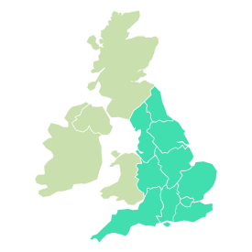   | In this campaign, there is a role for everyone. Since the middle of last year, we have begun to train up campaigners all around the country.  We have talked to lots and lots of different people.    It has been great to find that everyone we’ve talked to has been excited about the campaign.  Lots of people have told us they’re ‘In’.    We asked lots of the groups we visited to make a video telling us that. Do you want to meet some of the people who sent their videos in?  [Play ‘We’re in’ video]  [Go to the next slide]
   | Now, we can record our own ‘We’re In’ video if we want to!  Or we can go Live on Facebook.  [Go to the next slide.]
      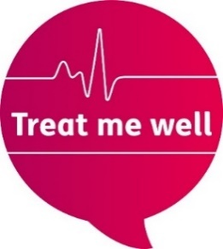 | We are nearly at the end of the official presentation for the Treat me well launch.  What’s next for the campaign?  Anyone who signed up to join the campaign earlier today will begin to get emails which will tell you a story about a person called Rachel and her experience in hospital.  Look out for the episodes of the story which will be released every few weeks.  If you did not sign up earlier today, please go to the Mencap website or social media channels to sign up.  Please start planning for Learning Disability Week when we will be taking our campaign directly to the nurses, doctors and hospital workers.    Learning Disability Week is from the 18th to the 22nd June. It will be an exciting chance for campaigners to arrange events with their local hospitals.    If you are interested in starting to campaign in your local area on health, please get in touch with our team.    More information for local campaigners will be coming out later this year, once the campaign is launched.
   | Now, all that is left to say is a huge thank you to all of you for coming.  Don’t forget to keep tweeting and posting about the campaign on social media using the hashtag #TreatMeWell.  And check out the website for more information about the campaign at www.Mencap.org.uk/TreatMeWell  You have all helped us give our new campaign, Treat me well, a wonderful launch.    Enjoy the rest of your day and see you soon!

