Thank you for deciding to fundraise for us. We appreciate your support!
Everyday Hero
Online Fundraising Guide

Our Giving Portal FAQ

How do I create a fundraising page?
- Go to www.everydayhero.co.uk/event/belfastmarathon
- Click on “Start Fundraising”
- Enter your name, email address and phone number and create a password (if you haven’t fundraised with us before)You can also use Facebook to login so that you don’t have to remember another password!
- Give your fundraising page a name (this will appear on your fundraising page and when you share your fundraising page with your social networks)
- Then you’re done! Now time to get fundraising!

Go the extra mile and personalise your fundraising page to make it easier to reach your goal
- Upload a profile photo so that your friends and family recognise your fundraising page
- Write a bit about why you are fundraising for this amazing cause in “My Story”
- Start promoting your fundraising page with friends and family by sharing the URL or posting an update and clicking the Twitter and Facebook icons next to “Post Now”
- Keep everyone updated on your progress by posting additional updates as you continue to fundraising and prepare for the event. You can add additional photos to make your fundraising page really unique.

How do I add more pictures to my fundraising page?
Look for this icon on your fundraising page.
Whether you’re using your computer or your phone, you can choose a photo to upload. If you’re on the move – snap a photo and instantly post.

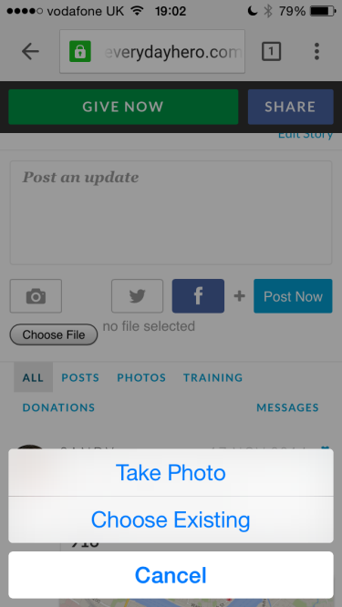

Can I add a video to my fundraising page?
You can add a video to your fundraising page, just like you would post an update. Grab the video link from where it is hosted (for example YouTube provides you with a sharing link).
Copy and paste this link into the update box of your fundraising page. Click Post Now, and your video will be embedded onto your fundraising page.

Can I link my fundraising page to Facebook or Twitter?
Yes! You can share your fundraising updates and posts with your social networks with the click of a button. Look for these buttons next to your posts and updates. Click the social networking icon(s) you want to include in your update.
Remember, this is a great way to get your friends and family involved and remind them to sponsor you and our cause.

Can I use my smartphone to fundraise?
Yes! Our Giving Portal works seamlessly on mobiles and tablets. You can use it to set up your page and share with friends and family. They can also make donations to your page safely and securely via a mobile-optimised webpage.

Can I create/join a team?
Yes! You have links on the right-hand side of your fundraising page which let you create a new fundraising team or join an existing one.

Click Join an existing team
- Using the search box, enter the name of the team. Once found, click “Join This Team”.The team owner will be notified of your request to join their team.

Click Create a new team
- Give your team a name and click “Create Team”
- Now you need to personalise the Team Page, like you personalised your own page
- Add a team photo and edit the story to be relevant for you and your group
- You’ll see your page listed under “Team Members” with a Gold Star – this means you are the Team Captain
- Click on “Invite Members” to get your friends and family involved. They’ll receive an email asking them to join your team. As Team Captain, you can review the team members and pending invites by clicking the link “Show All Members and Invites” at any time.

How safe/secure is this system?
Our Giving Portal uses state of the art online security for processing payments safely and securely. Your credit card details are never stored. And by using this portal, our organisation will receive the monies safely in our bank accounts with minimal delay.

What is Gift Aid and why is it showing on my fundraising page?
Gift Aid is a simple way to increase the value of gifts of money received from UK taxpayers. For every £1 qualifying donation received, we can claim repayment of 25 pence. All you need to do is tick the Gift Aid box and encourage eligible friends and family to do it too. For more information about Gift Aid, visit http://www.hmrc.gov.uk/

Why can’t I use JustGiving or VirginMoneyGiving?
You can use whichever fundraising platform you prefer as we appreciate every effort made to support our cause. However we have worked with a partner called everydayhero to design a fundraising portal which puts our cause first. With their help, we designed this fundraising portal for you to use to raise awareness and support our mission. It’s easy to use and will help you reach your target faster and easier – and everydayhero ensures that the money you collect gets delivered straight to us with minimal fees and processing time. Features include social sharing, blog-style updating and safe and secure donation processing. Sharing your page really helps as your friends and family get a chance to learn more about our organisation and mission; widening the reach of our cause.

Who can I call if I need assistance?
You can call our Supporter Service line 02890 691351 If you have questions about the Giving Portal specifically, you can also reach out to our Donor Service Line on 0845 680 9719.

